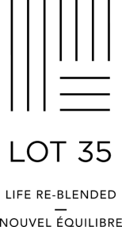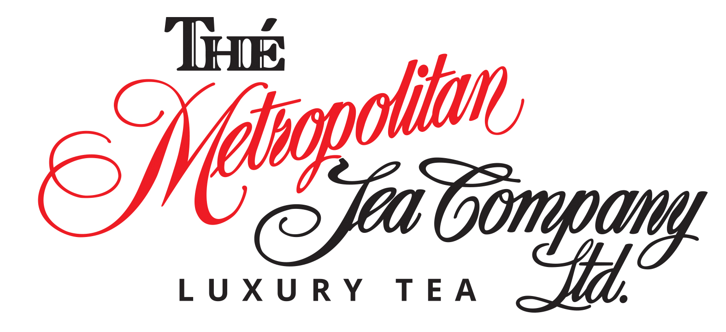**Use the LOT35 TRAINING BOOK to complete the following test**

**Refer to the TEA PROFILES section for questions pertaining to cup descriptions**

**Should you require any assistance (or hints) please reach out to** [**sales@metrotea.com**](mailto:sales@metrotea.com)

**Please email the test to** [**sales@metrotea.com**](mailto:sales@metrotea.com) **to obtain your Certificate of Completion**

**Name:** Click here to enter text.

**Hotel Property:** Click here to enter text.

1. **What company manufactures Lot 35 teas and where are they based?**

Click here to enter text.

1. **What special “distinction” has the company earned?**

Click here to enter text.

1. **What are the four main tea varieties and what plant do they come from?**

Click here to enter text.

1. **What is the Banana Analogy as it pertains to tea?**

Click here to enter text.

1. **What are the two basic leaf styles of black tea? What is the major difference between the two?**

Click here to enter text.

1. **Name four Lot 35 black teas and provide a brief cup description for each.**

Click here to enter text.

1. **List four characteristics and/or serving recommendations for black tea**

Click here to enter text.

1. **What method(s) are used to halt the oxidation process of green tea?**

Click here to enter text.

1. **List two Lot 35 green teas and provide a brief cup description for each**

Click here to enter text.

1. **Green tea contains more caffeine than black tea**

True False

1. **Oolong tea is best served as-is, with no milk or sugar**

True False

1. **White tea has higher antioxidants content than black tea**

True False

1. **List four Lot 35 herbal teas and provide a cup description for each**

Click here to enter text.

1. **Herb + Fruit teas are caffeine - free**

True False

1. **What year was the tea bag said to have been created?**

2737 BC 1657 1839 1908

1. 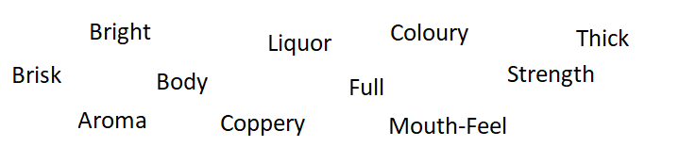**Match the words with the correct definitions.**

|  |  |
| --- | --- |
| Click here to enter text. | Brewed tea – the liquid in the cup |
| Click here to enter text. | the right balance of colour and strength. |
| Click here to enter text. | The smell or scent denoting the inherent character one should expect from a brewed tea |
| Click here to enter text. | A cup with deep colour indicative of strength. |
| Click here to enter text. | A lively visual appearance. This is what we look for in the cup liquor (brewed tea). |
| Click here to enter text. | A tea with a full, well-balanced astringency that satisfies all the taste receptors in the mouth. |
| Click here to enter text. | The brightly, copper coloured leaves of black tea. Coppery colour is indicative of well-manufactured tea. |
| Click here to enter text. | The substance of the cup. (Typically the result of brewing time. The longer the brew, the stronger the cup). |
| Click here to enter text. | Tea that exhibits fullness and strength |
| Click here to enter text. | Liquor with excellent colour and strength. |
| Click here to enter text. | A bright, lively character that surprises the taste buds. Indicative of well made tea. |

1. **List twelve primary growing regions used in Lot 35 teas**

Click here to enter text.

1. **Describe what to look for in Sri Lanka (Ceylon) black tea, and name a Lot 35 tea that contains Sri Lanka**

Click here to enter text.

1. **Which is country is considered the birthplace of tea?**

India England Japan China

1. **Describe what to look for in Kenya black tea, and name a Lot 35 tea that contains Kenya**

Click here to enter text.

1. **Describe what to look for in Darjeeling black tea, and name a Lot 35 tea that contains Darjeeling**

Click here to enter text.

1. **Describe what to look for in Assam black tea, and name a Lot 35 tea that contains Assam**

Click here to enter text.

1. **Describe what to look for in Japanese green tea**

Click here to enter text.

1. **Where can the world’s best Camomile be found? What makes it so good?**

Click here to enter text.

1. **Where is Lot 35 peppermint grown? What makes it so good?**

Click here to enter text.

1. **Describe what to look for in Rooibos, and name a Lot 35 tea that contains Rooibos**

Click here to enter text.

1. **List four best practices when serving pyramid tea bags or loose tea. Which do you consider to be the most important and why?**

Click here to enter text.

1. **Serving suggestions – for each of the following categories please check which condiments should be served.**

**Black Tea**

Milk Sugar/ Honey Lemon

**Green Tea**

Milk Sugar/ Honey Lemon

**Oolong Tea**

Milk Sugar/ Honey Lemon

**White Tea**

Milk Sugar/ Honey Lemon

**Herbal & Wellbeing Tea**

Milk Sugar/ Honey Lemon

**Herb and Fruit Tea**

Milk Sugar/ Honey Lemon

**Rooibos Tea**

Milk Sugar/ Honey Lemon

1. **“A perfect all day breakfast blend combining tea from the world’s best growing regions. Flavourful with strength and a delicious tea character.” Is a description for which tea?**

Imperial Breakfast Decaffeinated English Breakfast

Creamy Earl Grey Orange Pekoe

1. **Long Island Strawberry is described as “Very refreshing and reflective. Lush sultry summer strawberry notes fill the cup”. What type of tea is it?**

Black Tea Oolong Tea Herbal Tea Green Tea

1. **Which one of the below teas is naturally caffeine free and its ingredients list includes cucumber, tomato and citrus pieces?**

Market Fresh Joie de Provence Cold ‘n Flu

Skin & Beauty  Bella Coola Punch

1. **List at least five things that make Lot 35 teabags unique.**

Click here to enter text.

1. **What is the WORST thing you can do when preparing tea for guests?**

Make it too strong Make it too weak

1. **What is the recommended steeping time for Herb + Fruit teas?**

2-3 minutes 4-5 minutes 6-7 minutes 9-10 minutes

1. **When preparing iced black teas, the liquid may turn cloudy. This is normal, and a sign of high quality tea.**

True False

1. **The best way to sweeten iced tea is with granulated sugar.**

True False

1. **You should keep separate serving vessels for coffee and tea to ensure there is no flavor transfer.**

True False

1. **Which of the following is NOT a true statement about Lot 35 teas**

Made in a solar powered facility

Grown on family farms

Plant based no plastic tea bags

Fairtrade certified

1. **Refer to the Allergens section of the Tea Sommelier Portal and identify which allergens are present in the same manufacturing factory**

Click here to enter text.

1. **Refer to the Lot 35 Products section and list the 6 different categories of the Lot 35 program**

Click here to enter text.

1. **Refer to the Nutritional section and identify how many calories per one cup of Imperial Breakfast**

Click here to enter text.

1. **Refer to the Tea Profiles section and identify the cup characteristics of Kyushu Japan Sencha**

Click here to enter text.

1. **You have a guest with children who want to enjoy a High Tea. What teas would you suggest for the children and why?**

Click here to enter text.

1. **A guest is looking for a sleepy time tea, which would you suggest and why?**

Click here to enter text.

1. **A guest has just had a delicious and filling dinner. They would like a nice cup of tea to help with digestion, which would you suggest and why?**

Click here to enter text.

1. **Which is your favourite Lot 35 tea and why?**

Click here to enter text.